PROJECT CLOSURE CERTIFICATE

Date: {{End_Date}}

This is to certify that the below mentioned student has completed the assigned work successfully at National Remote Sensing Centre, Hyderabad during the period: {{Start_Date}} to {{End_Date}}.

STUDENT NAME: {{Student_Name}}

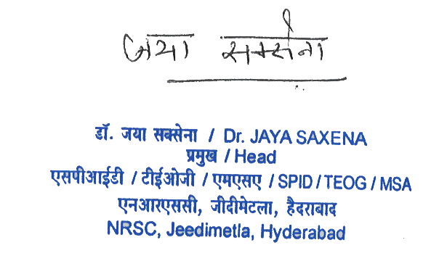

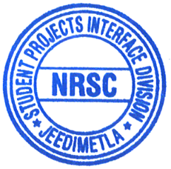
Dr. Jaya Saxena
Scientist 'F' & Head
Student Project Interface Division
Training, Education & Outreach Group
Management Systems Area (MSA)
NRSC (ISRO), HYDERABAD

